Overview
The board is programmed using Arduino’s IDE (Integrated Development Environment). At the time of this writing the present version was 3.0a, but for the most part things should be similar with upgrades. You should use the latest versions of all software unless otherwise indicated.

Preparation

Step-by-Step Instructions:

Installing IDE programming tools

Option 1: Web based instructions with link
This Adafruit link should have everything to install IDE and the Adafruit SAMD Board (the MMUS is an Adafruit Feather M0 Adalogger, which is a type of SAMD board).

Option 2: Step by step from developer
Installing IDE
- Download the most recent version of Arduino IDE for your computer from https://www.arduino.cc/en/software/. IDE is Arduino's Integrated Development Environment and provides a way to communicate and program your Adafruit Feather based MMUS.
Install IDE Third Party Board link
- Open IDE and go to File Preferences…
- Scroll towards the bottom and in “Additional Boards Manager URLS” type in https://adafruit.github.io/arduino-board-index/package_adafruit_index.json
- Click OK
- Click OK
Install IDE Board
- Open IDE and go to Tools Board Boards Manager (or ctrl-shift-B).
In the area at top, type in Adafruit SAMD. Click “INSTALL” for “Adafruit SAMD Boards” by Adafruit. AT the time of this writing, version 1.7.17 was active.
Install Required Libraries (ONLY if needed)
- Most libraries you will need are automatically installed. Please let the developer know if you run into problems
- If any are not installed, they will show up in a compilation error. Required libraries will all be listed in the first few lines of the MMUSxxxx.ino file. The line will start with “#include “and then the library name.
- Here are the most likely missing libraries, any others that show up in the error report can be installed. Details are in the MMUS “.ino” file #includes” to install them
- First, select "Tools Manage Libraries" and the library manager will show up on the left side of the screen
- Type in "SdFat" and select "INSTALL" for SdFat – Adafruit Fork by Bill Greiman” (you will have to scroll down to it
- Type in "RTClib" and select "INSTALL" for “RTClib by Adafruit” if it isn't already installed
- Type in "Arduino Low Power" and select "INSTALL" for “Arduino Low Power by Adafruit” if it isn't already installed. Click Install All if it states there are dependencies such as RTCzero

Programming

Files
Copy both the entire “MMUS…” and “Set_Date_Time…” folders to your computer.

Step One: Setting the Real Time Clock (RTC)
We HIGHLY suggest you use Greenwich Mean Time (Universal Time) if you are in an area where daylight savings time can change. Daylight savings time is the bane of accurate time-based scientific studies. The MMUS will stay at whatever time you set it unless it suffers a reset.
Open “Set_Date_Time_On_MMUS” (should automatically use IDE) from inside the “Set_Date_Time… folder you copied earlier.
Plug the MMUS boards into your computer using a USB-micro connector. This means you need to connect from the Feather M0 Adalogger side; the IO board side’s USB-C only has power connection and cannot transfer data.
In the IDE. Using the “Select Board” pull down, select Adafruit Feather Mo
Click the “Upload” button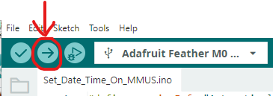
If the upload fails, you may need to double click the reset button on the Feather until the red LED slowly fades in and out. Then select the correct board again using the pull-down menu (it will likely change)
- Feather Reset button location
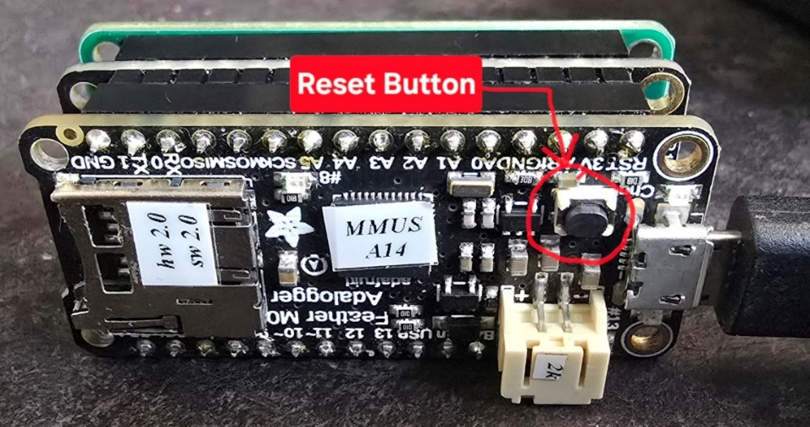
- IOB Reset Button location
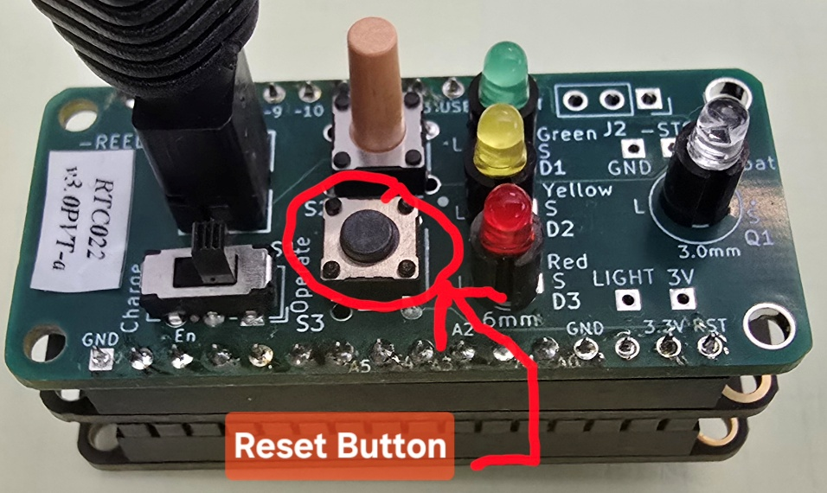
- RTC Reset Button
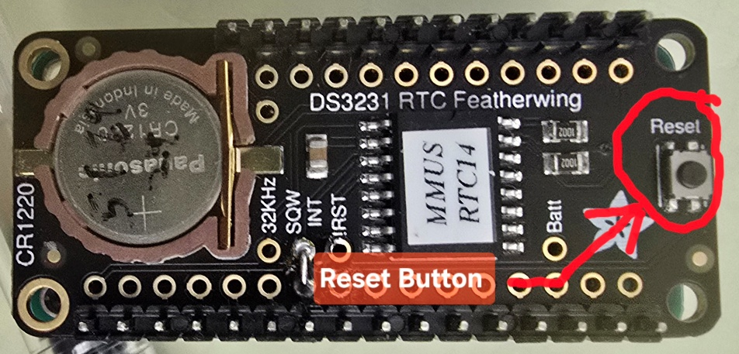
The red light will blink rapidly and you will get a “Done” message in the IDE window.
Now select Tools Serial Monitor
You will get a message for the moment the MMUS was booted. If you want to see it updated, type “n” in the “message” line of the serial port screen.
The present RTC time is: YYYY-MM-DD HH:MM:SS
- Where YYYY is the four-digit year
- The first MM is the two-digit month (i.e. 02 is February)
- DD is the two-digit day
- HH is the 2-digit hour in 24-hour time (i.e. 12 AM is 00 and 3 PM is 15)
- The second MM is the number of minutes using two digits
- SS is the number of seconds using two digits
If you want to see it updated, type “n” in the “message” line of the serial port screen
Follow instructions until you get the time set the way you want it. When setting the seconds (or anything), you can type in the value you want and wait until you hit the enter key for it to be entered into the RTC.
When satisfied, close the “Set_Date_Time_On_MMUS” window and proceed to the next step.

Step two: Programming the MMUS
Open the latest revision of MMUS (should automatically use IDE) from inside the “MMUS…” folder you copied earlier.
Open the “MMUS.h” tab in the IDE.
- On or about line 3 there will be a line similar to the following
const int MMUS_ID = 20;
- Change the number after the equal sign to reflect the ID Number you want for this unit. The ID number can be anything from 0 to 999 but a) NO leading 0’s, b) maximum 3 digits, c) maximum 120 for units that use rtivity for post processing (rtivity limitation if you are using the ID feature).
Plug the MMUS boards into your computer using a USB-micro connector. This means you need to connect from the Feather M0 Adalogger side; the IO board side’s USB-C only has power connection and cannot transfer data.
In the IDE. Using the “Select Board” pull down, select Adafruit Feather M0
Click the “Upload” button
If the upload fails, you may need to double click the reset button (see Figure 1 on page 2) on the Feather until the red LED slowly fades in and out. Then select the correct board again using the pull-down menu (it will likely change)
Note: If you get a notice about installing a boot loader or other messages, ignore them.
The red light will blink rapidly and you will get a “Done” message in the IDE window.
After this point, the serial monitor will no longer work as MMUS goes to sleep. You will have to reference the MMUS guide to determine what is happening.

Code Compiler Option Settings
I can’t go into all the options available in the code—there are many. If you want to do something special, it is possible the code may already be easily reconfigured to do what you want. MMUS.h documents many of the options and the #defines (switches) that enable the options or change the settings.
You can select the kind(s) of files you wish to save in the MMUS.h header file before compiling the code.
#define rtivity // tells code to make an rtivity format tab separated values file without any headers .tsv
#define csvFormatted // tells code to make a more readable csv formatted file with headers for excel or other analysis
#define WRITE_TO_SDCARD // enables writing to the SD Card if this line is uncommented. Comment to disable SD
normalWriteMode defaults to a one-minute storage interval at the top of the minute. This can be modified by changing normalRecTimeInterval.

